ABOUT THE WATERMILL THEATRE

The Watermill Theatre is a regional powerhouse, consistently making an innovative contribution to the vibrant and diverse landscape of UK Theatre reaching far beyond the 200 seats of the theatre itself. One of the most beautiful theatres in the country, it can be found nestled on the banks of the River Lambourn, in the hamlet of Bagnor, just outside Newbury, Berkshire. The theatre sits at the heart of its community to whom it offers a wide programme of work, nurturing emerging artists, generating new pieces and offering a thriving Outreach programme.

‘a paradigm of what a regional theatre should be.’ Stephen Sondheim, 2020

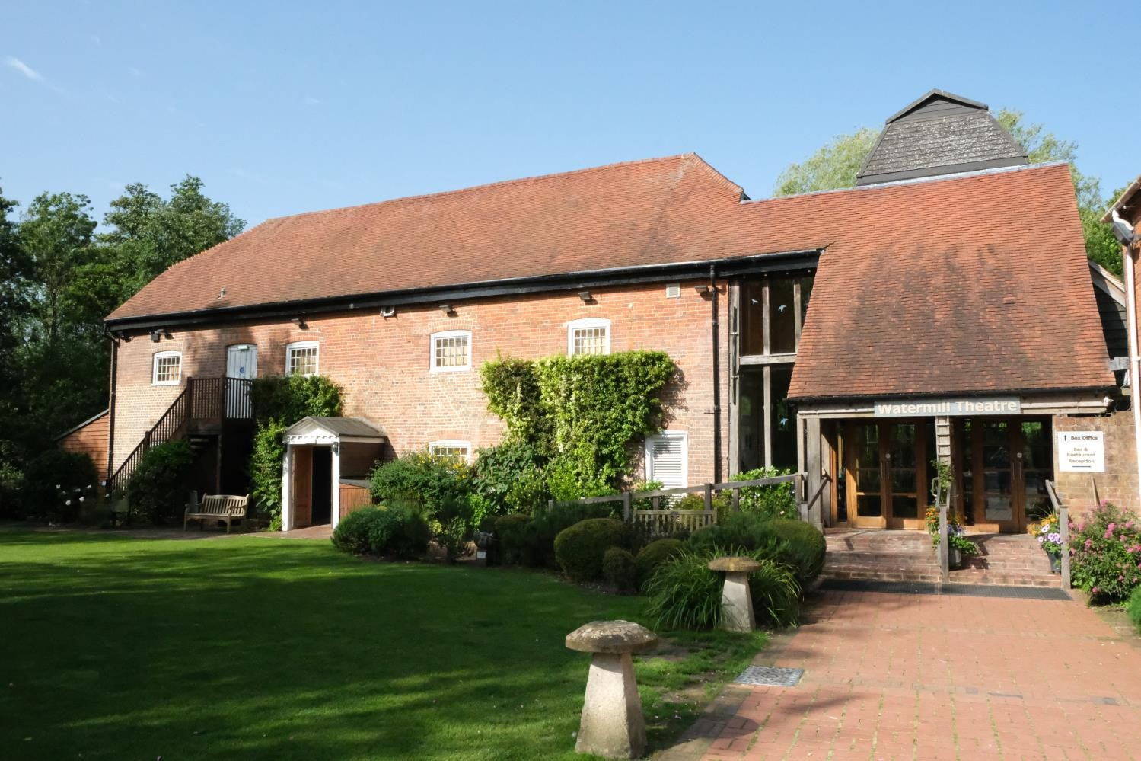
Approach to The Watermill Theatre & Restaurant.

BACKGROUND
Production photos from The Prince and the Pauper;
A Midsummer Night’s Dream; Kiss Me, Kate

From our home in a converted watermill in rural West Berkshire, The Watermill Theatre has produced award-winning work that has been recognised throughout the UK and abroad. The very best artists and creative teams, both established and in the early stages of their careers, are our lifeblood, earning The Watermill a reputation as one of the very best producing theatres in the country.

Our artistic ambition is shown in our choice of work, from new writing and musicals to Shakespeare and classic plays. We have become a leading figure in the work of actor-musicianship; our bold approach to this work has led to innovative reimagining's of large-scale musicals and classics as well as applying this approach to the development of new work.

Recent tours and transfers have included Amélie The Musical (National Tour and The Other Palace), The Wipers Times (West End and Tour), A Midsummer Night’s Dream and Macbeth (National Tour and Wilton’s Music Hall), Crazy For You (National Tour), Trial By Laughter (National Tour), Burke and Hare and One Million Tiny Plays About Britain (Jermyn Street Theatre), Twelfth Night (Wilton’s Music Hall), Teddy (National Tour and The Vaults).

Alongside transfers and national and international tours of our work, we create productions for small-scale touring, ensuring that those living in rural isolation are able to enjoy high quality theatre on their doorstep. We also tour to schools taking new interpretations of classic texts into the classroom to support students’ learning.

The theatre also runs its own restaurant and bar from the beautifully converted and recently refurbished 18th century tithe barn, situated adjacent to the theatre. Our Restaurant serves fresh home cooked and where possible locally produced food for our audience. In addition, our beautiful venue is available to hire for parties, wedding receptions, meetings and seminars.
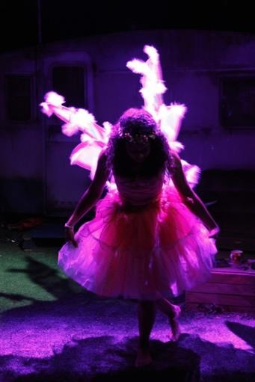
Production photos from The Wicker Husband; Jerusalem; The Prince and the Pauper

‘the first English theatre to open a new play commissioned and rehearsed since the
restrictions were relaxed.’ BBC News.

Following the forced closure of the theatre in mid-March due to Coronavirus we have faced enormous challenges. However, we have shown huge resilience over the last year, and as soon as we were given the green light to start creating live performances in August, we were quick to react. To this end, we were one of the first theatres in the country to present live performances with a season of outdoor theatre over a 6-week period. With social distancing in place, we reopened our auditorium for indoor performances, albeit at a reduced capacity. With the introduction of Tier 4 our theatre closed once more and remains so though online streaming enabled nearly 1000 households to watch our new adaptation of A Christmas Carol over the festive period. We look forward to being able to open the theatre’s doors once more.

ABOUT THE ROLE

Role Description

Role title: | Outreach Assistant
Salary: | £19,000 - £22,000 (Depending on experience)
Holidays | Statutory including public holidays
Probationary period: | 3 months
Other benefits: | Complimentary tickets for Watermill shows (subject to availability). Pension contribution matched up to 5%. The opportunity to work at one of the most beautiful theatres in the country.
Working hours: | Your normal working week will consist of those hours necessary to carry out the responsibilities of your position which should be based on a 40 (forty) hour week, with core hours of 10am – 2pm Monday to Friday.  Please note some Sunday work may be required when overtime will be paid.
Reports to: | Outreach Director

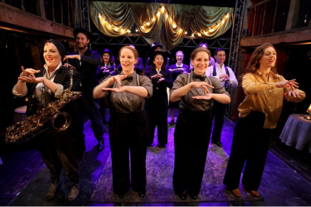
Photos from: Twelfth Night (BSL Integrated
Performance); Fourth Wall; Duologue

OUTREACH AT THE WATERMILL
Our belief that everyone deserves a chance to take part has led to a thriving education and participation programme, which works with around 19,000 people every year at The Watermill and in the wider community. We have a large youth theatre (around 300 children) with an extensive waiting list and run many projects with schools and other organisations in the local area.

The Outreach department consists of three full time staff, the Outreach Director, Outreach Assistant and Community Associate, and a team of up to 30 freelance artists – actors, directors and teachers, that deliver our work for us.

THE ROLE
We are looking for an enthusiastic, organised and ambitious person who is committed to supporting a busy and thriving department. The Outreach Assistant supports the Outreach Director and the wider Outreach department by co-ordinating our educational, youth and community opportunities. The role is largely administrative, but also involves facilitating and assisting outreach workshops. There will be regular evening hours and the occasional weekend work.

Our Outreach Assistant will work closely with young people and adults at risk; therefore, a full DBS check will be required.

Key Responsibilities
- Support the Outreach Director in the overall running of the department.
- Fully administrate the weekly Outreach programme to include: managing the waiting list, liaising with parents/guardians, sending out groups invitations and organising the payment of termly fees.
- Send invitations, take bookings and oversee the delivery of holiday courses, adult courses and other events within the department.
- Respond to enquiries about workshops, set them up and arrange invoices.
- Respond to enquiries, arrange interviews, and timetable successful work experience placements.
- Ensure all necessary departments are aware of outreach work and manage room bookings to avoid clashes.
- Liaise with the marketing team to ensure courses are advertised and that they have all necessary materials to promote the outreach work.
- Facilitate or assist educational/community workshops where needed.
- Regularly update outreach resources including the theatre’s visual story, the youth theatre information pack and copy for the website.
- Create education packs for main house productions, in consultation with the Outreach Director.
- Assist the Outreach Director in ensuring that the department complies with Child Safety and Protection law.
- Represent The Watermill at events including talks with local community groups, career fairs in schools and network meetings with other theatres.

Essential Criteria
- A strong work ethic and a commitment to supporting and growing the work of the Outreach Department.
- Exceptional organisational, time management and administrative skills.
- Flexibility and willingness to embrace change, learn from others and share ideas.
- Excellent and effective written and verbal communication skills.
- Previous experience using Microsoft Office products (Word, Excel, Teams).
- Strong interpersonal skills, with the ability to interact with people of all ages, within a range of contexts.
- A committed team player and pro-active self-starter.
- An interested and informed knowledge of live performance and theatre.
- A passion for theatre in community and school settings and a firm belief in its power to benefit the local community.
- A desire to develop project management and leadership skills.
- Suitability to work with children and adults at risk.
- Experience of leading or assisting drama workshops.
- A full, clean driving license, ability to drive, and the use of a car.

Desirable criteria
- Experience or understanding of Spektrix ticketing system
- Education to degree level

This job description is indicative of the responsibilities and duties associated with this position.
It is neither restrictive nor inclusive and does not form part of the contract of employment.

The Watermill Theatre reserves the right to make reasonable changes to this job description.

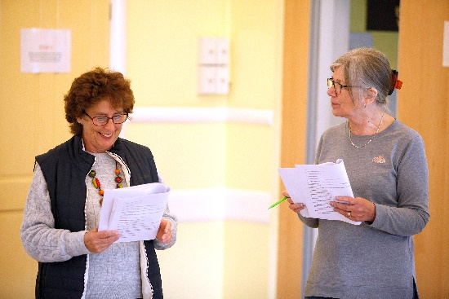

Photos from weekly Youth Theatre and adult groups

HOW TO APPLY

We actively encourage applications from people from a variety of backgrounds, experiences and skills as The Watermill Theatre is committed to equal opportunities for all. We also encourage people who do not necessarily meet these criteria but believe they could challenge our thinking and ensure the theatre’s future resilience.

To Apply
Please send us the following:
- Your CV
- A covering letter explaining how you fit the criteria.
- A completed Equal Opportunities Monitoring Form.

If we can support your application by offering an alternative format, please do let us know. Likewise, we want to ensure interviews are as accessible as possible so please do let us know in your application if there is anything we can do to support this.

Application Deadline: Thursday 24th June
Interviews: Interviews to be held on Monday 5th July, via Zoom. We may recall successful candidates, if necessary.

If invited to interview, we will:
- Pay for your travel costs to attend interviews where these take place in person.
- Pay for childcare (or other caring obligations) to enable you to attend interview.
- Pay for reasonable expenses.
- Make any reasonable adjustments that would assist you — for example, having a BSL interpreter if you would like this.
- We guarantee a first stage interview for disabled candidates who meet the minimum requirements for the role. Please state this on your application where you would like this to be considered.

Applications should be sent to admin@watermill.org.uk
or by post to:

Julie Pearson,
Administration Secretary
The Watermill Theatre
Bagnor, Newbury
Berkshire RG20 8AE

