ABOUT THE WATERMILL THEATRE

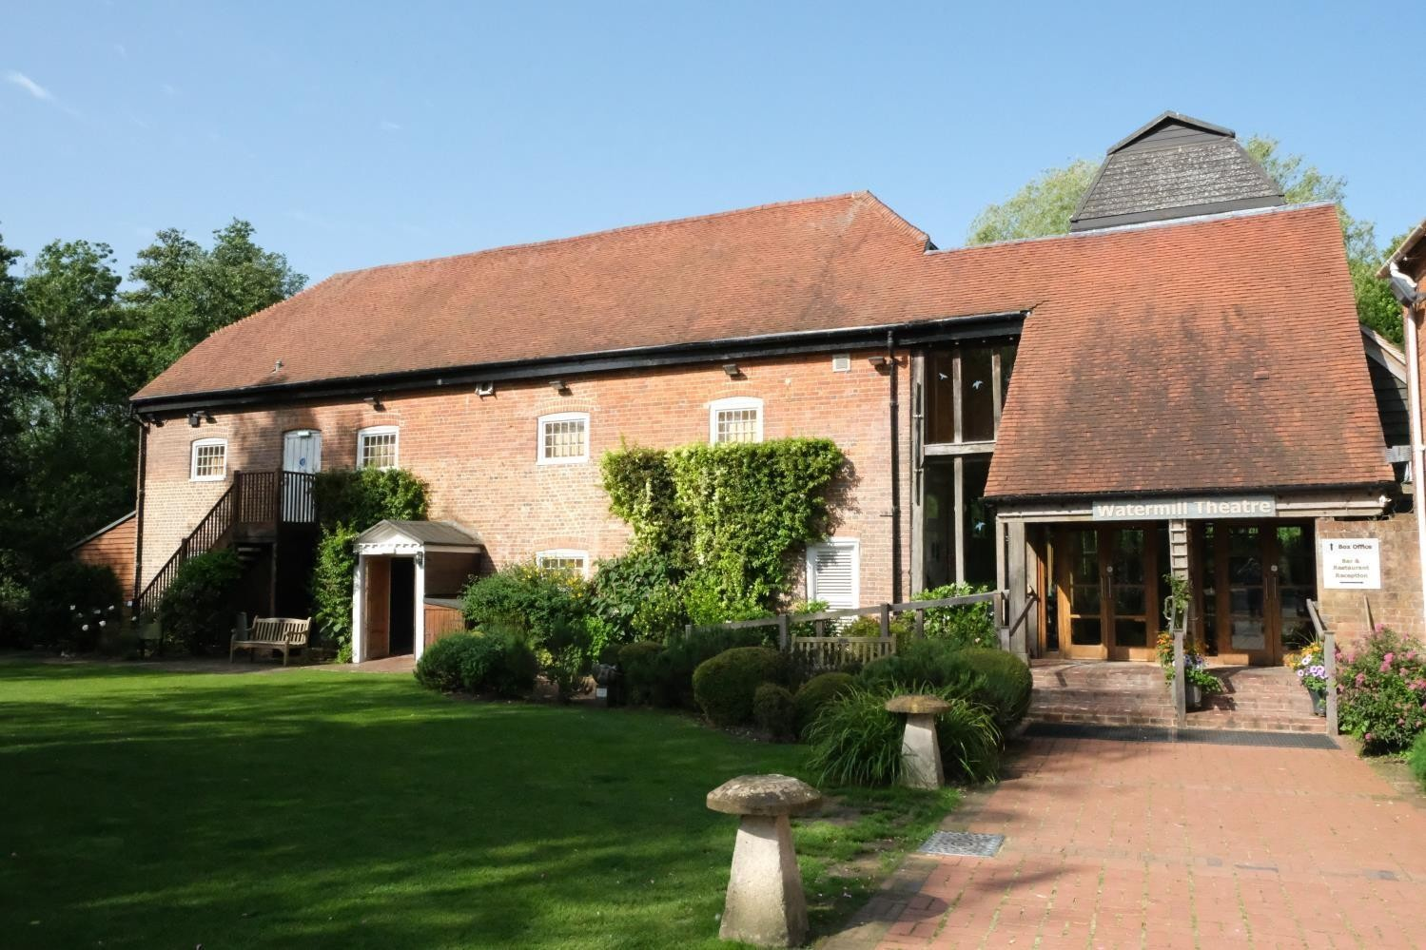
The Watermill Theatre is a regional powerhouse, consistently making an innovative contribution to the vibrant and diverse landscape of UK Theatre reaching far beyond the 200 seats of the theatre itself. One of the most beautiful theatres in the country, it can be found nestled on the banks of the River Lambourn, in the hamlet of Bagnor, just outside Newbury, Berkshire. The theatre sits at the heart of its community to whom it offers a wide programme of work, nurturing emerging artists, generating new pieces and offering a thriving Outreach programme.

‘a paradigm of what a regional theatre should be.’ Stephen Sondheim, 2020

Approach to The Watermill Theatre & Restaurant.

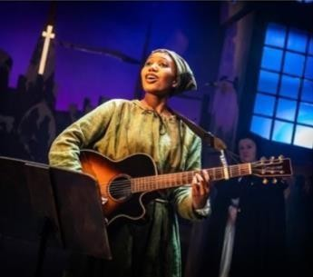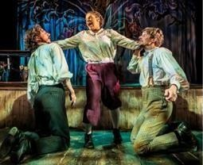

BACKGROUND
Production photos from The Prince and the Pauper;
A Midsummer Night’s Dream; Kiss Me, Kate

From our home in a converted watermill in rural West Berkshire, The Watermill Theatre has produced award-winning work that has been recognised throughout the UK and abroad. The very best artists and creative teams, both established and in the early stages of their careers, are our lifeblood, earning The Watermill a reputation as one of the very best producing theatres in the country.

Our artistic ambition is shown in our choice of work, from new writing and musicals to Shakespeare and classic plays. We have become a leading figure in the work of actor- musicianship; our bold approach to this work has led to innovative reimagining's of large scale musicals and classics as well as applying this approach to the development of new work.

Recent tours and transfers have included Amélie The Musical (National Tour and The Other Palace), The Wipers Times (West End and Tour), A Midsummer Night’s Dream and Macbeth (National Tour and Wilton’s Music Hall), Crazy For You (National Tour), Trial By Laughter (National Tour), Burke and Hare and One Million Tiny Plays About Britain (Jermyn Street Theatre), Twelfth Night (Wilton’s Music Hall), Teddy (National Tour and The Vaults).

Alongside transfers and national and international tours of our work, we create productions for small- scale touring, ensuring that those living in rural isolation are able to enjoy high quality theatre on their doorstep. We also tour to schools taking new interpretations of classic texts into the classroom to support students’ learning.

The theatre also runs its own restaurant and bar from the beautifully converted and recently refurbished 18th century tithe barn, situated adjacent to the theatre. Our Restaurant serves fresh home cooked and where possible locally produced food for our audience. In addition, our beautiful venue is available to hire for parties, wedding receptions, meetings and seminars.

Following the forced closure of the theatre in mid-March due to Coronavirus we have faced enormous challenges. However, we have shown huge resilience over the last year, and as soon as we were given the green light to start creating live performances in August, we were quick to react. To this end, we were one of the first theatres in the country to present live performances with a season of outdoor theatre over a 6 week period. With social distancing in place, we reopened our auditorium for indoor performances, albeit at a reduced capacity. With the introduction of Tier 4 our theatre closed once more and remains so though online streaming enabled nearly 1000 households to watch our new adaptation of A Christmas Carol over the festive period. We look forward to being able to open the theatre’s doors once more.

‘the first English theatre to open a new play commissioned and rehearsed since the restrictions were relaxed.’ BBC News.

THE WATERMILL ENSEMBLE

The Watermill Ensemble is The Watermill Theatre’s resident Shakespeare Company. The Ensemble aims to use actor-musicianship to give the productions a new lease of life by weaving music into
the heart of the text creating fresh, dynamic and enlivened versions of Shakespeare’s plays. Established in 2017, past productions include Romeo & Juliet, Twelfth Night, A Midsummer Night’s Dream, Macbeth and in March 2020 plans were in place for a daring all-female production of Hamlet. The Ensemble has also toured around the UK and to Neuss Shakespeare Festival Germany, often with two productions in rep, with the aim of bringing these reworked versions of Shakespeare’s classics to audiences both old and new.

The Watermill Ensemble focuses on nurturing new talent; our rehearsal room is a collaborative and safe space where, in order to strip back the story, we question and challenge the assumptions and preconceptions surrounding it. A fusion of movement, musicianship and rigorous text work unlocks
the innate rhythms within the piece that give each production an irreverent energy. In past productions we have also incorporated live magic, British Sign Language and Video Projection to further enhance a character’s journey or develop a theme within the storytelling.

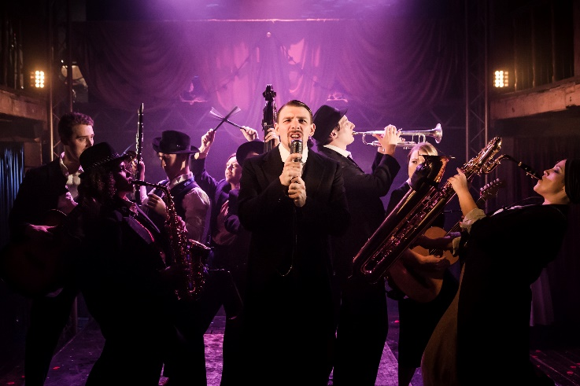
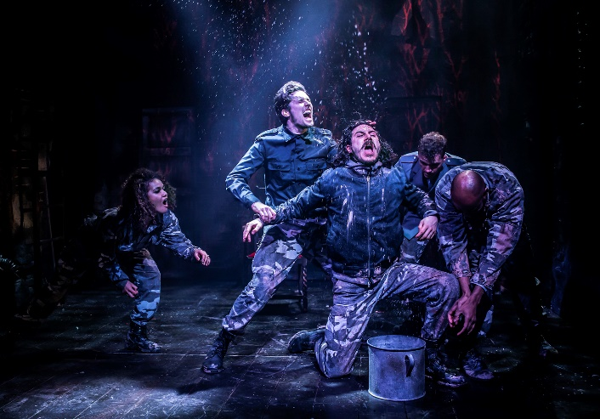

Productions photos from: Macbeth; Twelfth Night

ROLE SUMMARY

The Watermill Theatre is looking for an Assistant Director to work on our next Watermill Ensemble production, directed by Paul Hart. We encourage those in the early stages of their career to apply for this role.

The role as Assistant Director will involve some preparatory work prior to rehearsals. You will need to be available from 24 May – 28 June for rehearsals, tech week and press night, and to make two visits to The Watermill to note the show after it has opened.

Dates: Monday 24 May to Monday 28 June (inclusive)
Fee: £2,325
Accommodation: Provided at The Watermill or nearby

HOW TO APPLY

- Please complete this Application Form (note you will need to upload your CV and a
short Cover Note outlining your interest in the role)
- A completed Equal Opportunities Form

We actively encourage applications from people from a variety of backgrounds, experiences and skills as The Watermill Theatre is committed to equal opportunities for all. We also encourage
people who don’t necessarily meet these criteria but believe they could challenge our thinking and ensure the theatre’s future resilience.

Deadline: Friday 30th April
Interviews: To be held during the w/c 3rd May

If we can support your application by offering an alternative format please do let us know. Likewise, we want to ensure interviews are as accessible as possible so please do let us know in your application if there is anything we can do to support this.

Applications by post should be sent to:

Julie Pearson, Administration Secretary The Watermill Theatre Bagnor, Newbury Berkshire RG20 8AE

IF INVITED TO INTERVIEW WE WILL
- Pay for your travel costs to attend interviews where these take place in person.
- Pay for childcare (or other caring obligations) to enable you to attend interview.
- Pay for reasonable expenses.
- Make any reasonable adjustments that would assist you — for example, having a BSL interpreter if you would like this

We guarantee a first stage interview for disabled candidates who meet the minimum requirements for the role.

